**GEOS3102: Global Energy & Resources Labs**

Dietmar Muller, Tristan Salles, Amy I’Anson

Lab Overview

|  |  |  |  |  |
| --- | --- | --- | --- | --- |
|  | **Exercises** | **Weight** | **Due Date** | **Submission** |
| Lab 1 (Week 8) | Intro to Global Petroleum Resources and iPython | 10% | Thursday May 11 @ 9am | Madsen Dropbox |
| Lab 2  (Week 9) | Badlands | 15% | Thursday May 18 @ 9am | Madsen Dropbox |
| Lab 3 (Week 10) | Seismic Reflection Surveys | 15% | Thursday May 25 @ 9am | Madsen Dropbox |
| Lab 4 (Week 11) | Well Log Analysis | 15% | Thursday June 1 @ 9am | Madsen Dropbox |
| Lab 5  (Week 12) | Arafura Basin Petroleum Systems | 15% | Thursday June 8 @ 9am | Madsen Dropbox |
| Lab 6  (Week 13) | Tectonic Subsidence and Arafura Basin Report | 30% | Thursday June 15 @ 9am | Email [amy.ianson@sydney.edu.au](mailto:amy.ianson@sydney.edu.au) |

Each week a paper copy of the exercise will be provided for you. Please write neatly and clearly, messy and illegible reports will not be marked. You are also welcome to complete the exercise in the pdf available online. Remember to attach relevant maps and data.

Exercises are shown in grey boxes, answer in the space provided or attach your answer to the lab sheet.

**Your assignment is due Thursday the following week at 9am! 10% will be deducted per day late.**

Please note: You do not need to include your script for iPython practicals unless a question states “**Include your script”** in which case you only need to include the relevant portion of your script (please do not waste paper and print the entire script).

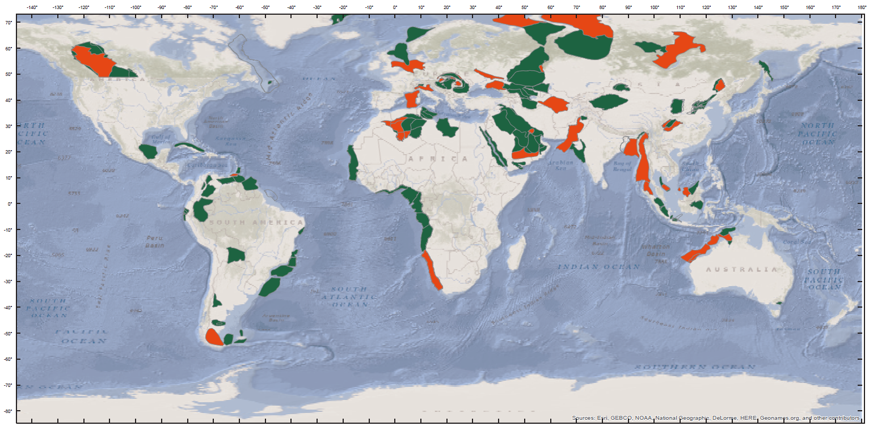Lab 1: Global Petroleum Resources

The main goal of this project is to help you get comfortable with iPython notebooks and to familiarise yourself with the language of the petroleum industry.

Petroleum is not distributed evenly around the world. More than half of the world’s proven oil reserves are located in the Middle East (including Iran but not North Africa); that is to say, the Middle East contains more oil than the rest of the world combined.

**Reserves** are identified quantities of “in-place” petroleum that are considered recoverable under current economic and technological conditions as estimated by petroleum engineers and geologists. Oil is measured in MMBO (million barrels) and Gas is measures in BCF (billion cubic feet)

Volumetric estimates of OOIP (original oil in place) and OGIP (original gas in place) are based on a geological model that geometrically describes the volume of hydrocarbons in the reservoir. However, due mainly to gas evolving from the oil as pressure and temperature are decreased, oil at the surface occupies less space than it does in the subsurface. Conversely, gas at the surface occupies more space than it does in the subsurface because of expansion. This necessitates correcting subsurface volumes to standard units of volume measured at surface conditions.

One basic volumetric equation is

N=7758Ah\phi (1-S_{{{\rm {w}}}})/B_{{{\rm {oi}}}}

Where;

* N = OOIP (STB)
* 7758 = conversion factor from acre-ft to bbl
* A = area of reservoir (acres) from map data
* h = height or thickness of pay zone (ft) from log and/or [core data](http://wiki.aapg.org/Overview_of_routine_core_analysis)
* ø = [porosity](http://wiki.aapg.org/Porosity) (decimal) from log and/or core data
* Sw = connate water saturation (decimal) from log and/or core data
* Boi = formation volume factor for oil at initial conditions (reservoir bbl/STB) from lab data

Another basic volumetric equation is

G=43560Ah\phi (1-S_{{{\rm {w}}}})/B_{{{\rm {gi}}}}

Where;

* *G* = OGIP(SCF)
* 43560 = conversion factor from acre-ft to ft3
* *B*gi = formation volume factor for gas at initial conditions (reservoir ft3/SCF)

Recoverable reserves are a fraction of the OOIP or OGIP and are dependent on the efficiency of the reservoir drive mechanism. The basic equation used to calculate recoverable oil reserves is OOIP multiplied by a recovery factor (given to you by your reservoir engineers and dependent on the drive mechanism of the field)

{\mbox{Recoverable oil reserves (STB)}}={\mbox{OOIP}}\times {\mbox{RF}}

Production profiles for conventional oil and gas wells vary substantially based on an array of geological and engineering parameters but almost always decline in an exponential fashion (as shown). Over time, the water cut (produced water as a % of total volume produced) will increase. 

Lab 1: Exercises

NAME: \_\_\_\_\_\_\_\_\_\_\_\_\_\_\_\_\_\_\_\_\_\_\_\_\_\_\_\_\_\_\_\_\_ SID: \_\_\_\_\_\_\_\_\_\_\_\_\_\_\_\_\_\_\_\_\_\_\_\_\_\_\_\_\_\_\_\_

In the first part of this exercise, we will introduce the Basemap library part of the python suite. This library can be used to create maps and plot geographical datasets. Python’s [matplotlib](<http://matplotlib.org/>) package is an amazing resource, and the [Basemap toolkit](<http://matplotlib.org/basemap/>) extends matplotlib’s capabilities to mapping applications.

We will use them to make maps of global hydrocarbon resources. The first thing consists in `importing` these libraries into our environment. The database you will be plotting comes from the USGS (<http://pubs.usgs.gov/dds/dds-069/dds-069-ff/downloads/GIS/metadata/>) and contains the following headers:

* Name
* GOR = Gas-Oil-Ratio
* O\_G = Primarily an oil or gas field
* CUM\_OIL = Cumulative oil produced
* REM\_OIL = Remaining oil
* KWN\_OIL = Known oil in place
* CUM\_GAS = Cumulative gas produced
* REM\_GAS = Remaining gas
* KWN\_GAS = Known gas in place

Q1. Run the code to produce two maps; Include your two maps in the appendix.

1. Plot the oil and gas provinces on the global map, coded by colour.
2. Plot the oil and gas provinces on the global map by known oil in place.

What do you notice about their distribution? Can you explain why this is the case?

\_\_\_\_\_\_\_\_\_\_\_\_\_\_\_\_\_\_\_\_\_\_\_\_\_\_\_\_\_\_\_\_\_\_\_\_\_\_\_\_\_\_\_\_\_\_\_\_\_\_\_\_\_\_\_\_\_\_\_\_\_\_\_\_\_\_\_\_\_\_\_\_\_\_\_\_\_\_\_\_\_\_\_\_\_\_\_\_\_\_\_\_\_\_\_\_\_\_\_\_\_\_\_\_\_\_\_\_\_\_\_\_\_\_\_\_\_\_\_\_\_\_\_\_\_\_\_\_\_\_\_\_\_\_\_\_\_\_\_\_\_\_\_\_\_\_\_\_\_\_\_\_\_\_\_\_\_\_\_\_\_\_\_\_\_\_\_\_\_\_\_\_\_\_\_\_\_\_\_\_\_\_\_\_\_\_\_\_\_\_\_\_\_\_\_\_\_\_\_\_\_\_\_\_\_\_\_\_\_\_\_\_\_\_\_\_\_\_\_\_\_\_\_\_\_\_\_\_\_\_\_\_\_\_\_\_\_\_\_\_\_\_\_\_\_\_\_\_\_\_\_\_\_\_\_\_\_\_\_\_\_\_\_\_\_\_\_\_\_\_\_\_\_\_\_\_\_\_\_\_\_\_\_\_\_\_\_\_\_\_\_\_\_\_\_\_\_\_\_\_\_\_\_\_\_\_\_\_\_\_\_\_\_\_\_\_\_\_\_\_\_\_\_\_\_\_\_\_\_\_\_\_\_\_\_\_\_\_\_\_\_\_\_\_\_\_\_\_\_\_\_\_\_\_\_\_\_\_\_\_\_\_\_\_\_\_\_\_\_\_\_\_\_\_\_\_\_\_\_\_\_\_\_\_\_\_\_\_\_\_\_\_\_\_\_\_\_\_\_\_\_\_\_\_\_\_\_\_\_\_\_\_\_\_\_\_\_\_\_\_\_\_\_\_\_\_\_\_\_\_\_\_\_\_\_\_\_\_\_\_\_\_\_\_\_\_\_\_\_\_\_\_\_\_\_\_\_\_\_\_\_\_\_\_\_\_\_\_\_\_\_\_\_\_\_\_\_\_\_\_\_\_\_\_\_\_\_\_\_\_\_\_\_\_\_\_\_\_\_\_\_\_\_\_\_\_\_\_\_\_\_\_\_\_\_\_\_\_\_\_\_\_\_\_\_\_\_\_\_\_\_\_\_\_\_\_\_\_\_\_\_\_\_\_\_\_\_\_\_\_\_\_\_\_\_\_\_\_\_\_\_\_\_\_\_\_\_\_\_\_\_\_\_\_\_\_\_\_\_\_\_\_\_\_\_\_\_\_\_\_\_\_\_\_\_\_\_\_\_\_\_\_\_\_\_\_\_\_\_\_\_\_\_\_\_\_\_\_\_\_\_\_\_\_\_\_\_\_\_\_\_\_\_\_\_\_\_\_\_\_\_\_\_\_\_\_\_\_\_\_\_\_\_\_\_\_

Q2. Produce a map of Australia showing oil and gas fields, produce a second map that shows oil and gas field by volume (include your map in your appendix, remember to include figure caption)

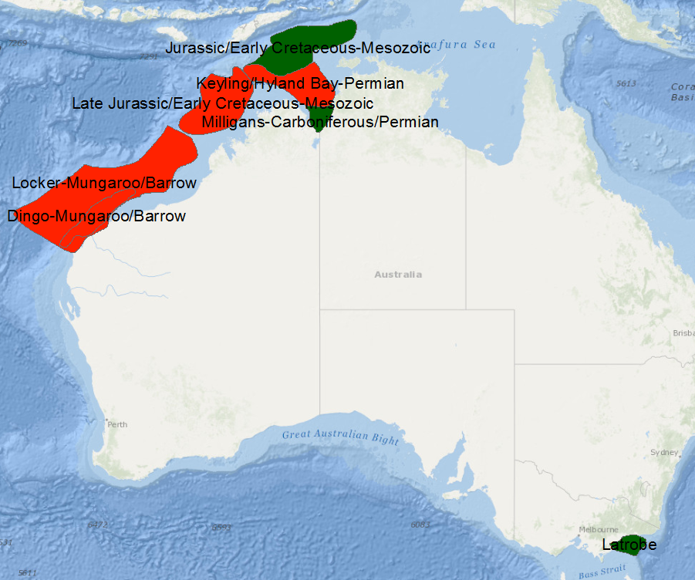Q3. Lookup the total oil and gas reserves for each field. Fill in the table below

|  |  |  |
| --- | --- | --- |
| **NAME** | **OIL** | **GAS** |
|  |  |  |
|  |  |  |
|  |  |  |
|  |  |  |
|  |  |  |
|  |  |  |
|  |  |  |

Q4. Zoom in on the Manqa oil province in the Red Sea. What do you notice about its geometry? Can you hypothesize the tectonic origin of this oil field?

\_\_\_\_\_\_\_\_\_\_\_\_\_\_\_\_\_\_\_\_\_\_\_\_\_\_\_\_\_\_\_\_\_\_\_\_\_\_\_\_\_\_\_\_\_\_\_\_\_\_\_\_\_\_\_\_\_\_\_\_\_\_\_\_\_\_\_\_\_\_\_\_\_\_\_\_\_\_\_\_\_\_\_\_\_\_\_\_\_\_\_\_\_\_\_\_\_\_\_\_\_\_\_\_\_\_\_\_\_\_\_\_\_\_\_\_\_\_\_\_\_\_\_\_\_\_\_\_\_\_\_\_\_\_\_\_\_\_\_\_\_\_\_\_\_\_\_\_\_\_\_\_\_\_\_\_\_\_\_\_\_\_\_\_\_\_\_\_\_\_\_\_\_\_\_\_\_\_\_\_\_\_\_\_\_\_\_\_\_\_\_\_\_\_\_\_\_\_\_\_\_\_\_\_\_\_\_\_\_\_\_\_\_\_\_\_\_\_\_\_\_\_\_\_\_\_\_\_\_\_\_\_\_\_\_\_\_\_\_\_\_\_\_\_\_\_\_\_\_\_\_\_\_\_\_\_\_\_\_\_\_\_\_\_\_\_\_\_\_\_\_\_\_\_\_\_\_\_\_\_\_\_\_\_\_\_\_\_\_\_\_\_\_\_\_\_\_\_\_\_\_\_\_\_\_\_\_\_\_\_\_\_\_\_\_\_\_\_\_\_\_\_\_\_\_\_\_\_\_\_\_\_\_\_\_\_\_\_\_\_\_\_\_\_\_\_\_\_\_\_\_\_\_\_\_\_\_\_\_\_\_\_\_\_\_\_\_\_\_\_\_\_\_\_\_\_\_\_\_\_\_\_\_\_\_\_\_\_\_\_\_\_\_\_\_\_\_\_\_\_\_\_\_\_\_\_\_\_\_\_\_\_\_\_\_\_\_\_\_\_\_\_\_\_\_\_\_\_\_\_\_\_\_\_\_\_\_\_\_\_\_\_\_\_\_\_\_\_\_\_\_\_\_\_\_\_\_\_\_\_\_\_\_\_\_\_\_\_\_\_\_\_\_\_\_\_\_\_\_\_\_\_\_\_\_\_\_\_\_\_\_\_

Q5. Familiarise yourself with the OOIP and OGIP equations. Define them as functions in iPython. Calculate the OOIP for a hypothetical 15000 acre field that contains a 3m thick sandstone reservoir of 10% porosity and 40% connate water saturation assuming a formation volume factor of 1.85.

\_\_\_\_\_\_\_\_\_\_\_\_\_\_\_\_\_\_\_\_\_\_\_\_\_\_\_\_\_\_\_\_\_\_\_\_\_\_\_\_\_\_\_\_\_\_\_\_\_\_\_\_\_\_\_\_\_\_\_\_\_\_\_\_\_\_\_\_\_\_\_\_\_\_\_\_\_\_\_\_\_\_\_\_\_\_\_\_\_\_\_\_\_\_\_\_\_\_\_\_\_\_\_\_\_\_\_\_\_\_\_\_\_\_\_\_\_\_\_\_\_\_\_\_\_\_\_\_\_\_\_\_\_\_\_\_\_\_\_\_\_\_\_\_\_\_\_\_\_\_\_\_\_\_\_\_\_\_\_\_\_\_\_\_

Q6. Calculate the OGIP for a hypothetical 9000 acre field that contains a 6m thick sandstone reservoir of 15% porosity and 20% connate water saturation assuming a formation volume factor of 1.1.

\_\_\_\_\_\_\_\_\_\_\_\_\_\_\_\_\_\_\_\_\_\_\_\_\_\_\_\_\_\_\_\_\_\_\_\_\_\_\_\_\_\_\_\_\_\_\_\_\_\_\_\_\_\_\_\_\_\_\_\_\_\_\_\_\_\_\_\_\_\_\_\_\_\_\_\_\_\_\_\_\_\_\_\_\_\_\_\_\_\_\_\_\_\_\_\_\_\_\_\_\_\_\_\_\_\_\_\_\_\_\_\_\_\_\_\_\_\_\_\_\_\_\_\_\_\_\_\_\_\_\_\_\_\_\_\_\_\_\_\_\_\_\_\_\_\_\_\_\_\_\_\_\_\_\_\_\_\_\_\_\_\_\_\_

Q7. For the La Trobe Oil field in the Gippsland Basin make a map of its location & back calculate the reservoir thickness given it is 30 000km2 in area with a porosity of 5% and a water saturation of 35%. Assume a formation volume factor of 1.9. **Include your script.**

\_\_\_\_\_\_\_\_\_\_\_\_\_\_\_\_\_\_\_\_\_\_\_\_\_\_\_\_\_\_\_\_\_\_\_\_\_\_\_\_\_\_\_\_\_\_\_\_\_\_\_\_\_\_\_\_\_\_\_\_\_\_\_\_\_\_\_\_\_\_\_\_\_\_\_\_\_\_\_\_\_\_\_\_\_\_\_\_\_\_\_\_\_\_\_\_\_\_\_\_\_\_\_\_\_\_\_\_\_\_\_\_\_\_\_\_\_\_\_\_\_\_\_\_\_\_\_\_\_\_\_\_\_\_\_\_\_\_\_\_\_\_\_\_\_\_\_\_\_\_\_\_\_\_\_\_\_\_\_\_\_\_\_\_

Q8. Your company, MDM (million dollar madness) decide to purchase the acreage that contains the East Natuna field in the South China Sea (off Northern Natuna Island in Indonesia). Design a map for your management that introduces them to the region.

Q9. You drill 9 exploration wells at $2M each in your field as well as 100km of seismic data at $100 000/km. It turns out your exploration was successful but the USGS grossly overestimated the gas reserve in place. Your exploration reveals the field is 70 000 acres with 5ft of a sandstone reservoir that has 8% porosity and only 20% water saturation. Calculate the gas reserves for this field. **Include your script.**

\_\_\_\_\_\_\_\_\_\_\_\_\_\_\_\_\_\_\_\_\_\_\_\_\_\_\_\_\_\_\_\_\_\_\_\_\_\_\_\_\_\_\_\_\_\_\_\_\_\_\_\_\_\_\_\_\_\_\_\_\_\_\_\_\_\_\_\_\_\_\_\_\_\_\_\_\_\_\_\_\_\_\_\_\_\_\_\_\_\_\_\_\_\_\_\_\_\_\_\_\_\_\_\_\_\_\_\_\_\_\_\_\_\_\_\_\_\_\_\_\_\_\_\_\_\_\_\_\_\_\_\_\_\_\_\_\_\_\_\_\_\_\_\_\_\_\_\_\_\_\_\_\_\_\_\_\_\_\_\_\_\_\_\_

Q10. **Advanced Only…** You carry out some appraisal testing at a cost of $12M and delineate that a recovery factor of 80% is appropriate for this field as there is good water drive. You decide you would like to go ahead with this venture and need to do some economic profiling. For every well you drill you can produce 8BCF of gas within that year. Each well has a cost $6M which includes environmental. You have the resources allowing you to drill 10 wells per year. We will simplify the case and assume the wells are online for 1 year.

You sell gas at $0.98M/BCF and have to build a $17M pipeline in the first year of production. Complete the profit and loss table. You may use python, excel, or a pencil and calculator.

|  |  |  |  |  |  |  |  |  |  |  |  |
| --- | --- | --- | --- | --- | --- | --- | --- | --- | --- | --- | --- |
|  | Year 0 | 1 | 2 | 3 | 4 | 5 | 6 | 7 | 8 | 9 | 10 |
| COSTS |  |  |  |  |  |  |  |  |  |  |  |
| INCOME |  |  |  |  |  |  |  |  |  |  |  |
| NET VALUE |  |  |  |  |  |  |  |  |  |  |  |